1. Create SpringBoot App
2. Create DockerFile and Add Below Content as per App

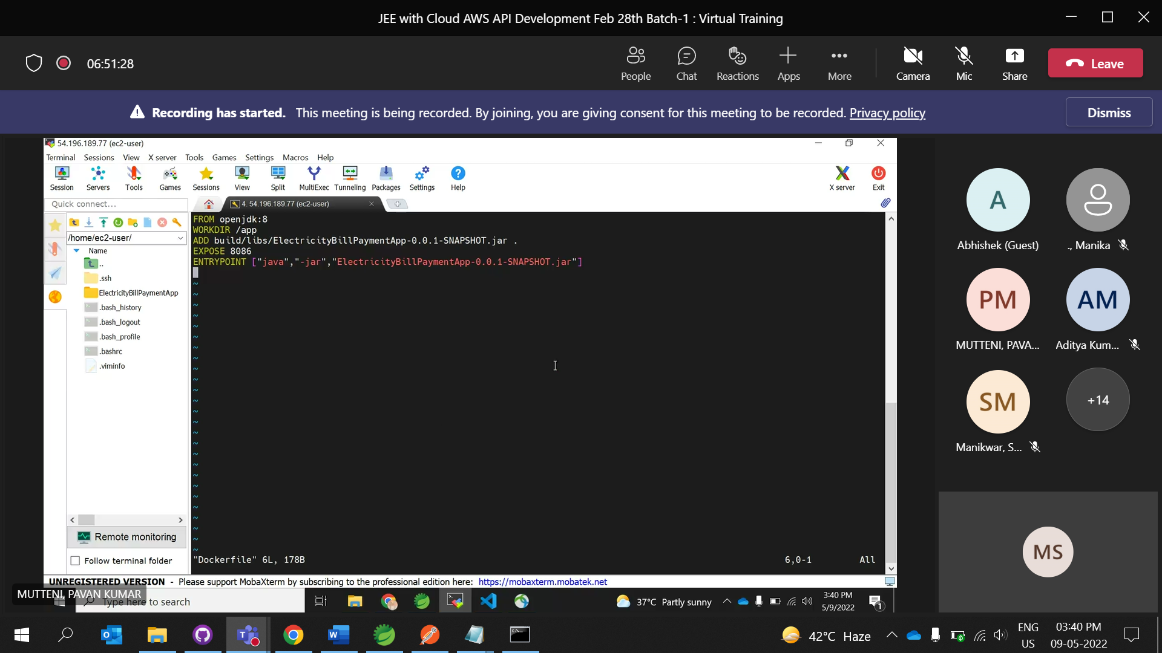

1. Generate Jar File of Application
   1. Add Dependency into build.gradle File to generate Jar

task fatJar(type: Jar){

manifest {

attributes 'Implementation-Title': 'Gradle Jar File Example',

'Implementation-Version': version,

'Main-Class': 'com.cg.CarParkingSytstemApplication'

}

baseName = project.name + '-all'

from { configuration.compile.collect { it.isDirectory() ? it : zipTree(it) } }

with jar

}

tasks.named('bootJar') {

launchScript()

}

* 1. Save and Refresh GradleFile
  2. Goto Project Root Directory and open cmd
  3. Run : gradle build

Or building Jar without Test Case : gradle build -x test

1. Now, Create Github Repository of Spring Boot Application
   1. Make sure to remove build/ from gitignore file Otherwise your build Jar file wont be uploaded on github.
2. Create EC2 Instance
   1. In Security Group set Type to All Traffic and Source to Anywhere
3. Install/Run Docker using below Command

sudo yum update -y;sudo yum install docker -y;sudo systemctl start docker;sudo usermod -a -G docker ec2-user;sudo systemctl enable docker;sudo systemctl status docker

docker info : to check it is working or not

1. Install Git

sudo yum install git

1. Re-login your Session
2. Now Copy Repository code HTTP URL from Github
3. Run Command instance : git clone <https://github.com/mossheik/CarParkingApplication.git>
4. Goto Application Directory Folder

cd CarParkingApplication

1. Locate and goto Dockerfile
2. Then in CarParkingApplication directory and Run

docker build -t app .

docker image ls : to check images

1. Create Network

docker network create myapp

docker network ls

1. Install Postgress image

docker container run --network=myapp --name=db -itd -e POSTGRES_USER=postgres -e POSTGRES_PASSWORD=1 postgres

docker container ls

1. Create container

docker container run -p 8080:9117 --network myapp --name springbootapp -itd -e SPRING_DATASOURCE_URL=jdbc:postgresql://db:5432/postgres -e SPRING_DATASOURCE_USERNAME=postgres -e SPRING_DATASOURCE_PASSWORD=1 app

docker container ls

1. Copy Public Address from AWS ec2 instance and view application in browser. Port is 8080.
2. View Database

Docker exec -it postgrescontainerid

Su -l postgres

psql